Literature Review Tools

Credit to Isaac Salisbury, who put this list together.

# Flavours of literature review (search strategy specified or mystery)

|  |  |
| --- | --- |
| Systematic | Non-Systematic |
| Types  * Systematic review * Meta-analysis * Bibliometric review  Steps  1. Pilot your search    * Search for key terms    * Filter for relevant publications    * Extract list of papers 2. Report your search criteria    * Prisma    * Equator network 3. Register your review    * Prospero    * ODF    * Cochrane Library    * Research Registry    * JBI    * InPlasy | Types  * Narrative review * Metanarrative review  Steps  1. Have a point 2. Iterate 3. Have fun with it   Can be framed by research question, topic, etc. |

# Literature Discovery (fantastic metadata and where to find them)

When a paper is published, it:

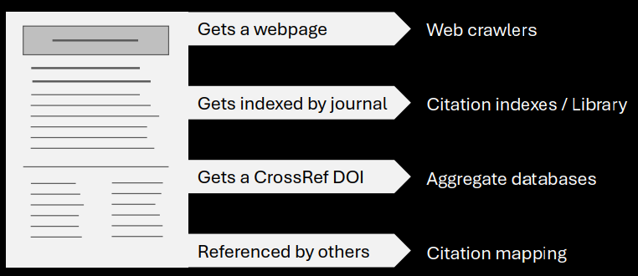

# Reference Managers (they’re all the same but Zotero is the best)

# Data Extraction (how much thinking do you want to do?)